**Deployment instruction**

1. **Java**
2. Install JRE6
3. In "Control Panel\System and Security\System\Advanced system settings\Environment Variables" add JAVA_HOME = [Java base] in system variables.

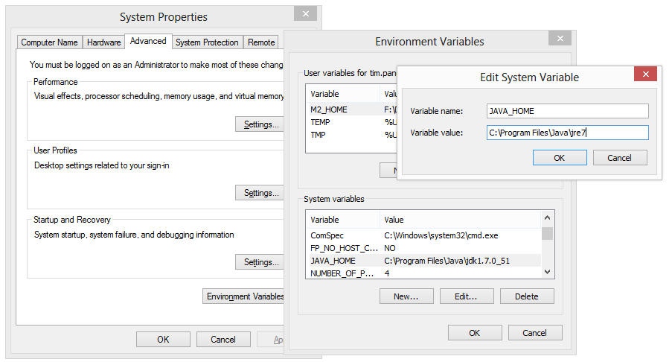

1. **Tomcat**
2. Extract Tomcat6
3. In "Control Panel\System and Security\System\Advanced system settings\Environment Variables" add CATALINA_HOME = [Tomacat base] in system variables.

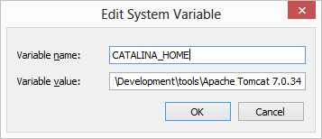

1. Open Tomcat port on firewall.

Open Windows Firewall with Advanced Security, click “Inbound Rules” node. Click “New Rule…” in the right window.

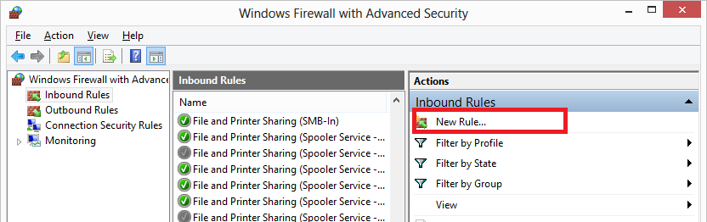

Select “Port” in the New Inbound Rule Wizard and click Next.

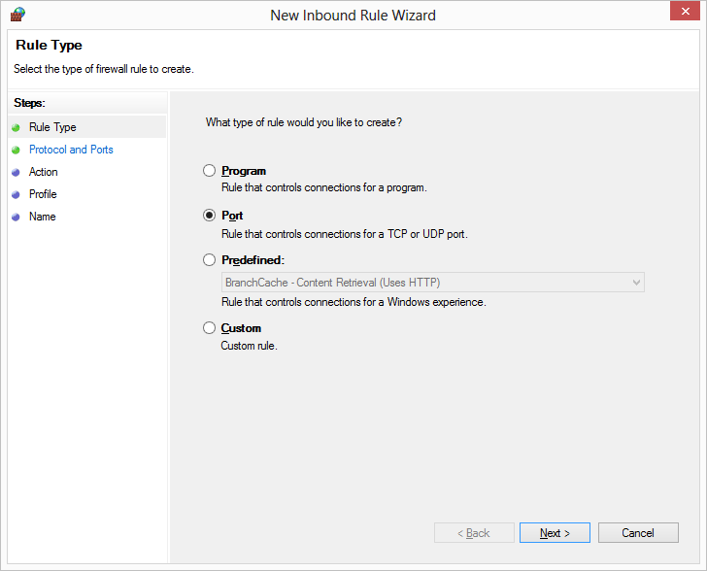

Add “8080” to “Specific local ports”, and click next.

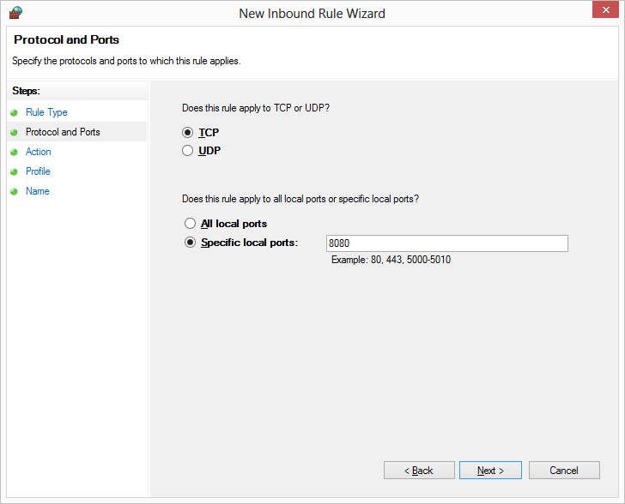

Select “Allow the connection” and click Next.

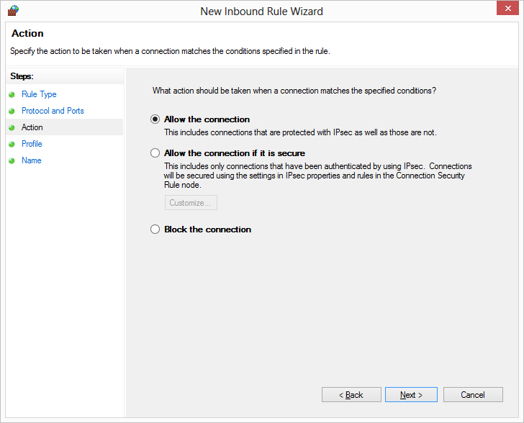

Tick “Domain”, “Private” and “Public” and click Next.

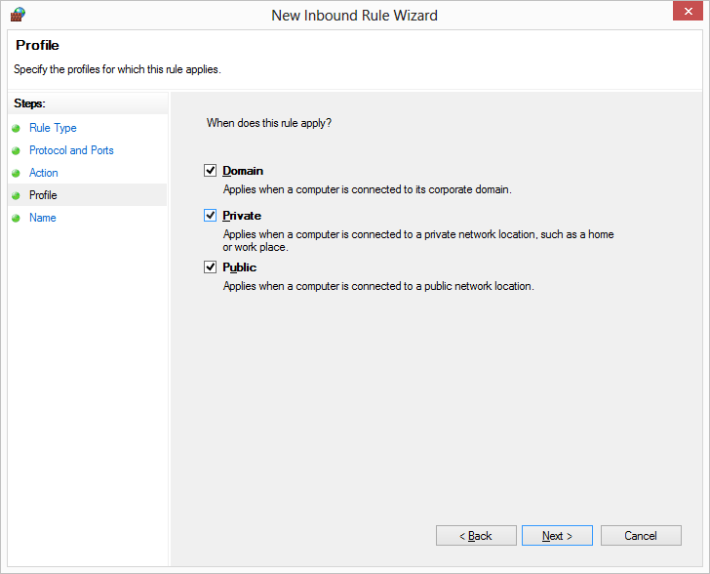

Give it a name of “Tomcat” and click Finish.

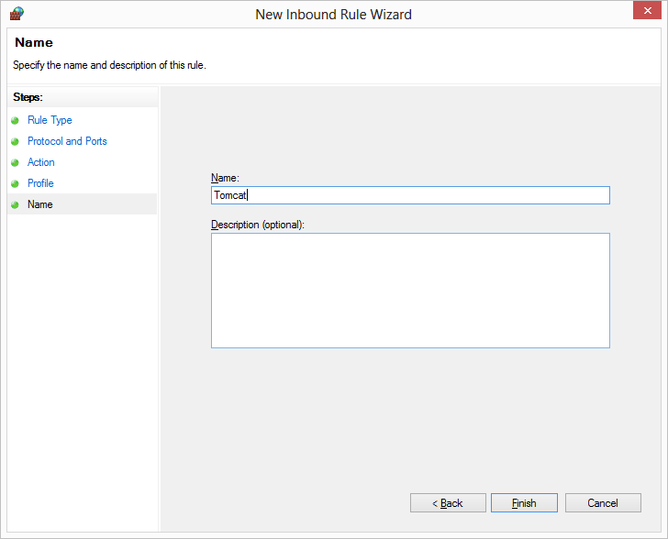

1. **Database**
2. Create NMIComment database and table in SQL server, table name is "NMIComment". This table has four columns:

|  |  |  |
| --- | --- | --- |
| Column Name | Data Type | Allow Nulls |
| id | nvarchar(50) | False |
| Column0001 | nvarchar(10) | False |
| Column0002 | nvarchar(MAX) | True |
| Column0003 | datetime | False |
| Column0004 | nvarchar(100) | True |
| Column0005 | nvarchar(100) | True |
| Column0006 | nvarchar(100) | True |

“id” is the primary key.

1. Enable TCP connection for SQL Server, and use 1433 as the fixed port.

Open SQL Server Configuration Manager, under the SQL Server Network Configuration node, select the Protocols for the local database instance. Right click “TCP/IP” on the right window and enable it.

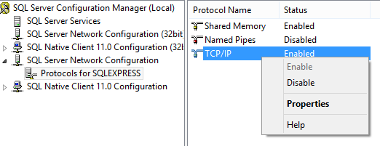

Double click “TCP/IP” and open TCP/IP Properties screen. In the IP Addresses panel, find “IPAll” node at the bottom. Clear “TCP Dynamic Ports” and set TCP port to “1433”

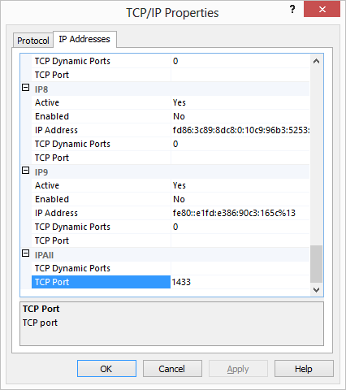

1. **Deploy application**

Place “Writeback.war” in “[Tomcat Base]\ webapps”. Startup Tomcat by running “[Tomcat Base]\bin\startup.bat”. Some user need to run the startup file with administrator’s role. Right click the file and select “Run as administrator”. When it is started, stop it by closing the Tomcat startup window.

Then check the ‘’[TomcatBase]\webapps” folder, there should be a “Writeback” folder extracted.

1. **Modify application configuration**

In [Tomcat base]\webapps\ Writeback\WEB-INF, open web.xml and edit highlighted parts below to the correct value.

1. database user name

<context-param>

<param-name>dbUser</param-name>

<param-value>sa</param-value>

</context-param>

1. database user password

<context-param>

<param-name>dbPassword</param-name>

<param-value>sa</param-value> </context-param>

<context-param>

1. Server domain and database name

<param-name>dbURL</param-name>

<param-value>jdbc:sqlserver://localhost:1433;databaseName=VRSailor</param-value>

</context-param>

1. **Start Tomcat**

Option a: run [Tomcat base]\bin\Startup.bat directly.

Option b: register Tomcat as Windows service. Run [Tomcat base]\bin\service.bat first and then start Tomcat7 in Windows Service.

1. **Access the application**

Once Tomcat is running, is able to access the application from URL <http://localhost:8080/Writeback/index.jsp?key=XXX&moreinfo=column4info,column5info,column6info>

“localhost” can be replaced with IP address and “XXX” should be replaced with real NMI numbers.

1. **Log files**

If there is any problem, log files should be collected to help analysis. Log files are in “[Tomcat Base]\logs” folder.